 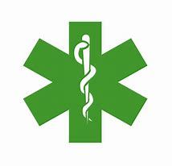 Occ. Health/Medical Dept. [tel: internal 3298/3333](tel:3298/3333)

**Boulby Control Room Operator 01287 646552 Medical Centre 01287 646523**

**Teesdock Control Room Operator: 01642 770500 (internal 4500)**

sickness absence line on **01287 646 652**

Date: 23rd December 2020 # 21

**Coronavirus (COVID-19): Latest information and advice.**

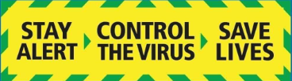

Contents

Recent site changes 1

Don’t become another statistic! 2

Are you aware of the recent government changes? 2

New variant of Coronavirus 2

Christmas Arrangements 2

Self-isolation and Christmas bubbles 3

After meeting your Christmas bubble 3

When returning to work 4

Symptoms and behaviours 4

Tier 2 – High Alert levels 4

Tier 3 – Very High Alert Levels 5

Tier 4 – Stay at home 5

Donning and Doffing Face Masks safely 6

Flu vaccine 6

Counselling and Bullying 7

# Recent site changes

From **Monday 21st December** it is a requirement for all persons on site to wear a face mask – this must be a clinical mask, FFP2, FFP3 or equivalent, the use of snoods or other similar face coverings are not deemed suitable as the origins and manufacture of such garments are varied and as a business we have no guarantee with regard the protective nature of these items.

This is over and above existing face mask usage, the wearing of coverings within site buildings will become mandatory, except: outdoors or within a well-ventilated area when >2m apart, when working alone, when at your desk, when eating, when showering or in changing rooms. This is in recognition of the awareness of a more contagious variant of the Coronavirus. Masks can be sourced from the sanitising stations, CRO’s or medics.

# Don’t become another statistic!

The opening up of some restrictions over Christmas will obviously be nice for us to be able to see family and friends that we may not have seen for some time. This will, undoubtably increase the risk of catching the virus by large numbers of people coming together, whilst the virus is still circulating in society. **Control over Christmas is in the hands of us all, as individuals and families**, make sure that when meeting people you exercise caution and implement the controls that we have all become used to over recent months. Regularly washing hands, wearing face coverings and keeping a safe distance. Don’t think you won’t catch the virus it is very contagious. **It is our responsibility to control the virus. Protect yourself, protect your loved ones and protect your colleagues.**

# Are you aware of the recent government changes?

It is vital that we each take personal responsibility this Christmas to limit the spread of the virus and protect our loved ones, [particularly if they are vulnerable](https://www.nhs.uk/conditions/coronavirus-covid-19/people-at-higher-risk/whos-at-higher-risk-from-coronavirus/). One in three people with coronavirus (COVID-19) have no symptoms and will be spreading it without realising it. So, the safest way to celebrate Christmas this year is with your household or existing support bubble in your home. The more people you see, the more likely it is that you will catch or spread coronavirus.

Self-isolation is essential to reducing the spread of COVID as it breaks the chains of transmission. After reviewing the evidence, the Government are now confident that we can reduce the number of days that contacts **self-isolate from 14 days to 10 days. This is effective from Monday 14th December 2020.**

People who return from countries which are not on the travel corridor list should also self-isolate for 10 days instead of 14 days.

People who test positive should continue to self-isolate for 10 days from onset of symptoms or 10 days from point of taking a positive test if asymptomatic.

# New variant of Coronavirus

A new variant of coronavirus has been found which is growing faster in some parts of England. At least 60 different local authorities have recorded Covid infections caused by the new variant - was now present in other areas of the country. The new variant could be up to 70% more transmissible than previous strains. Over the last week, there had been sharp, exponential rises in coronavirus infections across London, Kent, parts of Essex and Hertfordshire. Currently over 1,000 cases have been identified with this variant predominantly in the South of England.

# Christmas Arrangements

Making a Christmas bubble with family and friends

Following advice updated as of 22nd December.

Christmas bubbles, [support bubbles](https://www.gov.uk/guidance/making-a-support-bubble-with-another-household) and [childcare bubbles](https://www.gov.uk/guidance/making-a-childcare-bubble-with-another-household) are all different things and have their own specific rules.

The rules on Christmas bubbles are in law. You must follow the rules to minimise the spread of infection.

You can only form a Christmas bubble if you do not live in a Tier 4 area. If you are permitted to form a Christmas bubble and choose to do so:

* keep your Christmas bubble as small as possible. Two other households is a maximum, not a target
* do not join a Christmas bubble with anyone from a Tier 4 area
* stop all unnecessary social contact outside your immediate household as soon as possible and for at least five days before you meet other households in your bubble
* only meet your Christmas bubble in private homes or in your garden, places of worship, or public outdoor spaces
* only see your bubble on Christmas Day. Do not stay overnight and keep your visits as short as possible
* stay local where possible. Avoid travelling from a high prevalence to a low prevalence area
* if you are meeting someone who is not in your Christmas or support bubble, you can only do so outside your home or garden and in accordance with the rules in your tier (either the tier you live in, or the tier you are meeting in - whichever is stricter)

When seeing your Christmas bubble, you should keep taking steps to reduce the spread of the virus. This includes:

* meeting outdoors where possible
* ensuring indoor spaces get as much fresh air as possible
* making space between members of different households wherever you can
* washing your hands regularly and for 20 seconds
* following [rules on self-isolation](https://www.gov.uk/government/publications/covid-19-stay-at-home-guidance) if you develop symptoms or test positive for coronavirus.

You should not visit another household if you, or anyone in your household, is self-isolating. You should get [a free NHS test](https://www.gov.uk/get-coronavirus-test) if you have symptoms, have been asked to by your local council or your hospital, or are taking part in a government pilot project

# Self-isolation and Christmas bubbles

Remember to follow [rules on self-isolation](https://www.gov.uk/government/publications/covid-19-stay-at-home-guidance/stay-at-home-guidance-for-households-with-possible-coronavirus-covid-19-infection), which apply if either you, someone you live with, someone in your childcare or support bubble, or someone you have been in contact with, has symptoms or has tested positive for coronavirus. You should not form a Christmas bubble if you have coronavirus symptoms or are self-isolating as this poses a considerable risk to others.

If a member of your Christmas bubble tests positive for coronavirus or develops coronavirus symptoms on 25 December, or up to 48 hours after members of the bubble last met, all members of the bubble should [self-isolate](https://www.gov.uk/government/publications/covid-19-stay-at-home-guidance/stay-at-home-guidance-for-households-with-possible-coronavirus-covid-19-infection) as if they were members of the same household.

# After meeting your Christmas bubble

After meeting your Christmas bubble on 25 December, you should reduce your contact with people you do not live with as much as possible. While the rules relevant to your local tier will apply, you should exercise extra caution, and think carefully about whether to meet up with friends or family outside your household. This includes not meeting up with them for New Year’s Eve, even if you feel well. Around one in three people with coronavirus don’t have symptoms and can still pass it on.

You can go to work if you cannot work from home, but you should avoid unnecessary social interaction. Any increase in contact with other people increases the risk you will catch or spread coronavirus

# When returning to work

When returning to work after the Christmas and New Year festivities please remind yourself of the site barriers of control.

* Don’t come to work if feeling unwell
* Present yourself at the gatehouse for temperature checking
* Remember to stay 2m apart or if less than 2m then ensure additional precautions and measures are adopted.
* Frequently wash hands for more than 20 seconds and or use hand sanitiser
* Regularly clean down and wipe down your working area, equipment and tools with sanitising wipes
* Ensure there is adequate ventilation.
* Carry out point of work risk assessments to help identify hazards and appropriate solutions to reduce risk.
* Politely challenge those you feel are not following the guidelines
* Raise any concerns to your line manager where Covid barriers are either not being followed or could be improved.

# Symptoms and behaviours

It is critical that everybody observes the following key behaviours, if not the virus will become more prevalent in our environment. The prevalence of the virus is down to us ALL. We must comply with the barriers of control and reduce our tolerance to ‘complacency’.

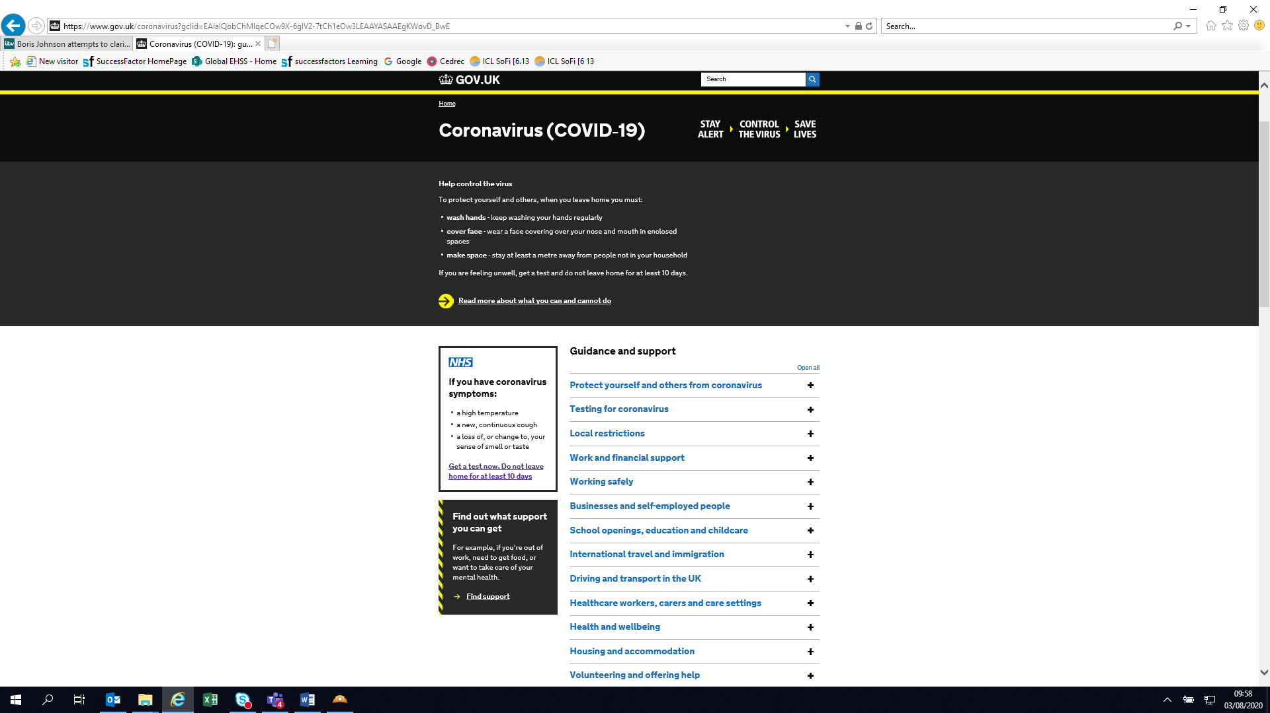 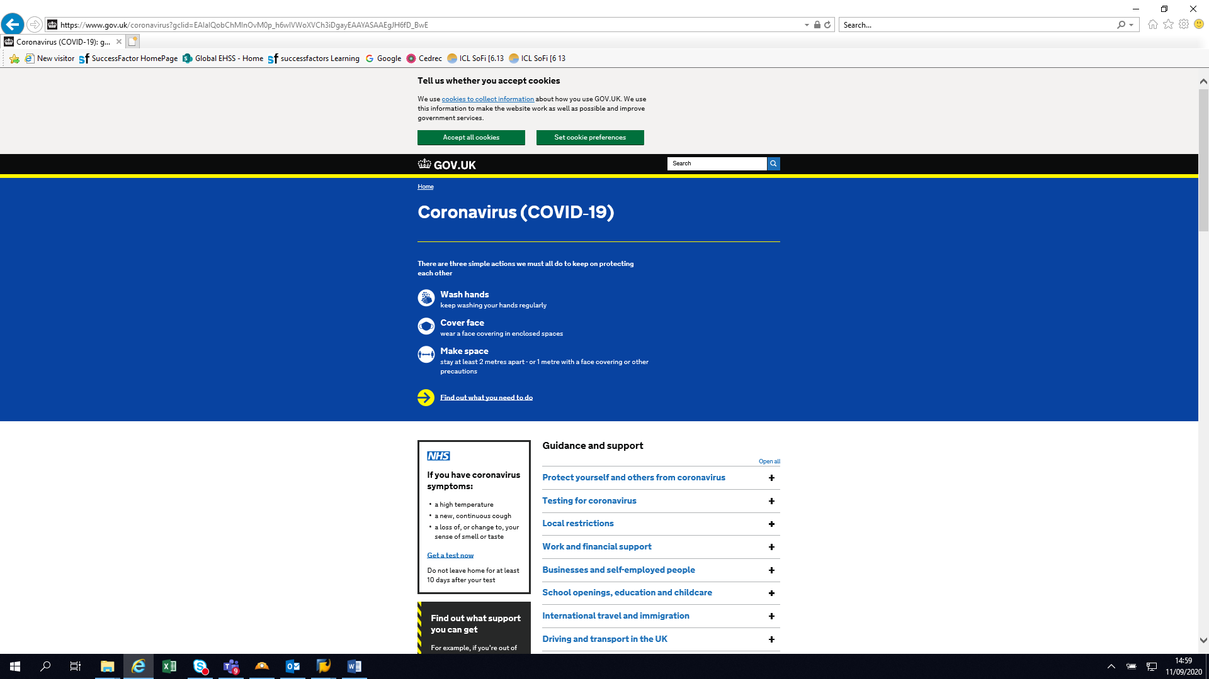

# Current cleaning services include:

1. On demand / notification of a ‘hot spot’ Deep Clean service – physical wipe down and fogger. Area then isolated for two hours to allow fogger mist to settle.
2. Overnight fogging of the admin block and midday deep clean wipe down of surfaces (by hand) in admin block conference rooms.
3. Changing rooms and control rooms twice daily deep clean and wipe down of surfaces.
4. Cleaning hourly of high touch areas – handles, switches etc

# Tier 2 – High Alert levels

# <https://www.gov.uk/guidance/tier-2-high-alert?priority-taxon=774cee22-d896-44c1-a611-e3109cce8eae>

# Tier 3 – Very High Alert Levels

<https://www.gov.uk/guidance/tier-3-very-high-alert>

# Tier 4 – Stay at home

<https://www.gov.uk/guidance/tier-4-stay-at-home?priority-taxon=774cee22-d896-44c1-a611-e3109cce8eae>

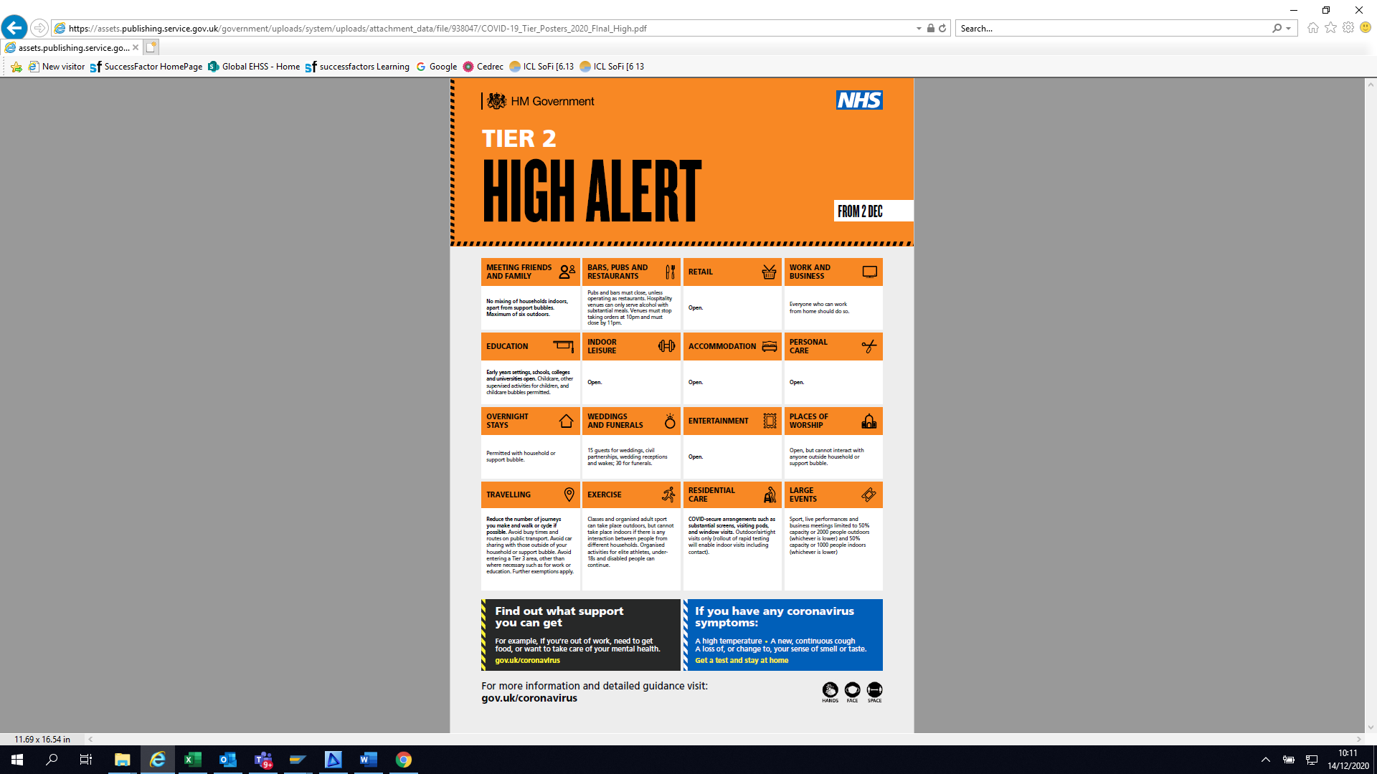 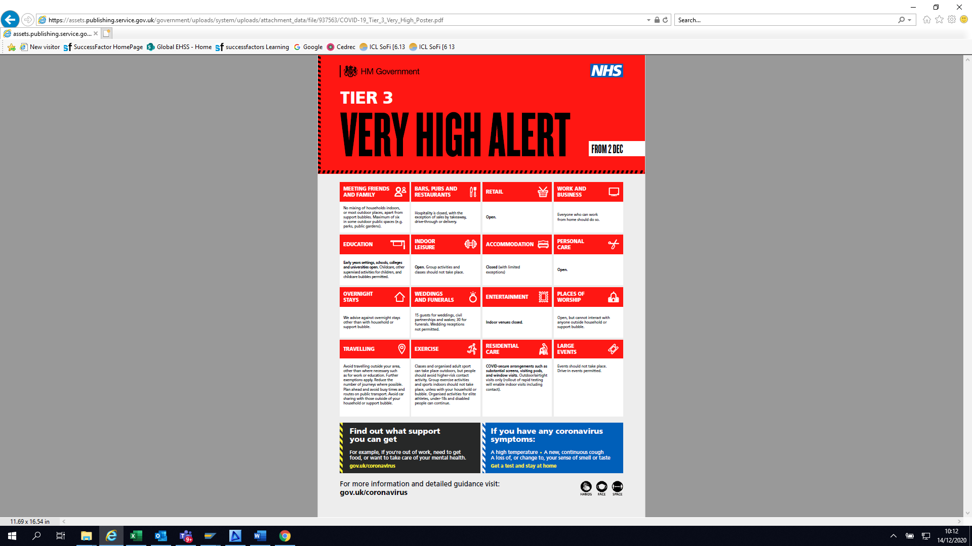

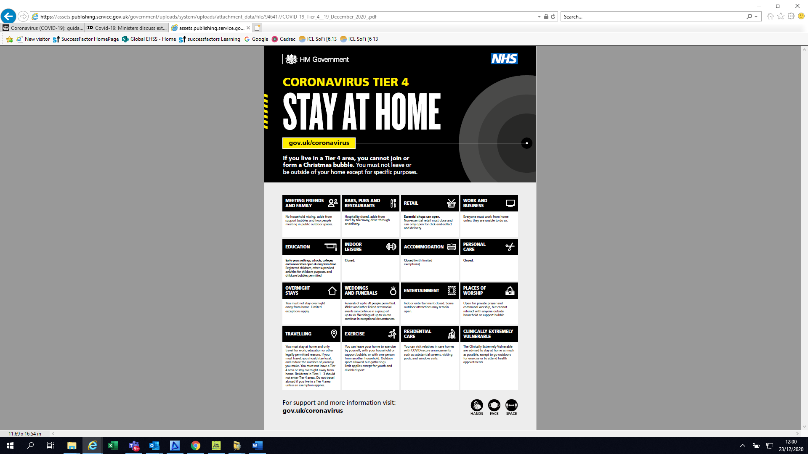

# Donning and Doffing Face Masks safely

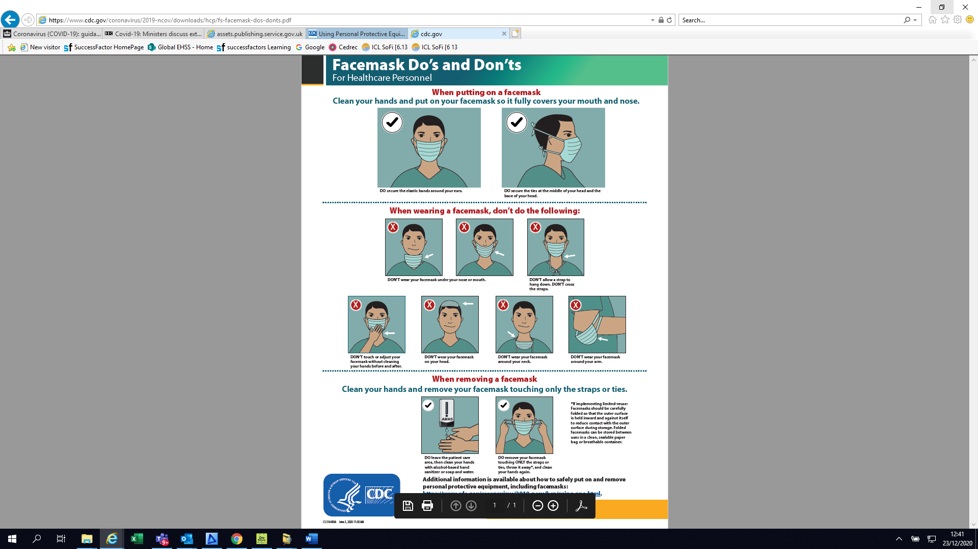

# Flu vaccine

The flu vaccine is a safe and effective vaccine. It's offered every year on the NHS to help protect people at risk of flu and its complications.

This information is about the flu vaccine for adults.

[Find out about the children's flu vaccine](https://www.nhs.uk/conditions/vaccinations/child-flu-vaccine/)

The best time to have the flu vaccine is in the autumn before flu starts spreading. But you can get the vaccine later.

**Flu vaccine and coronavirus (COVID-19)**

Flu vaccination is important because:

* if you're at higher risk from coronavirus, you're also more at risk of problems from flu
* if you get flu and coronavirus at the same time, research shows you're more likely to be seriously ill
* it'll help to reduce pressure on the NHS and social care staff who may be dealing with coronavirus

If you've had COVID-19, it's safe to have the flu vaccine. It'll be effective at helping to prevent flu.

**Who can have the flu vaccine?**

The flu vaccine is given to people who:

* are 50 and over (including those who'll be 50 by 31 March 2021)
* have certain health conditions
* are pregnant
* are in long-stay residential care
* receive a carer's allowance, or are the main carer for an older or disabled person who may be at risk if you get sick
* live with someone [who's at high risk from coronavirus](https://www.nhs.uk/conditions/coronavirus-covid-19/people-at-higher-risk/whos-at-higher-risk-from-coronavirus/) (on the NHS shielded patient list)
* frontline health or social care workers

**Where to get the flu vaccine**

* your GP surgery if you are in an eligible category
* a pharmacy offering the service
* your midwifery service if you're pregnant

If you have your flu vaccine at a pharmacy, you do not have to tell the GP. The pharmacist should tell them.

# Counselling and Bullying

The coronavirus (COVID-19) outbreak is having an impact on everyone’s daily lives. During this time, you may be bored, frustrated or lonely. You may also feel low, worried, anxious, or be concerned about your health or that of those close to you. These are all common reactions to the difficult situation we face.

It’s important that you take care of your mind as well as your body. Most people will find strategies that work for them and the difficult feelings associated with the outbreak will pass. Below are some links for telephone and online advice and guidance services that you may find useful:

<https://www.nhs.uk/oneyou/every-mind-matters>

<https://www.mind.org.uk/need-urgent-help/what-can-i-do-to-help-myself-cope>

Seven ways to get through Christmas <https://www.bbc.co.uk/news/uk-55399649>

Call Samaritans free on 116 123 or visit the Samaritans website

Shout 85258 offers confidential 24/7 crisis text support for times when you need immediate assistance. Text "SHOUT" to 85258.

We also provide a confidential counselling service which is available to all ICL employees. Please contact the **Medical Dept. on ext. 3296 or 01287 646523** if you feel you may benefit from this service.

We are aware that some individuals, upon returning to work following a positive Coronavirus test and following the prescribed isolation period, have been subject to unfavourable treatment. This is clearly unacceptable, any employee who does test positive will only return to the workplace after following their prescribed isolation period after which they will no longer be infectious.

Whilst workplace banter is important, it is more important to know that there is a fine line and not to cross it. We will not tolerate bullying and harassment. Harassment and Discrimination – Stops here! <https://www.youtube.com/watch?v=q47u5TRSBZQ&feature=youtu.be>